Lesson 12 – Project Setup Guide

# Opening the C286 VS Solution

1. Open **Visual Studio 2019**, under the **Open recent** list, double-click on **MyC286Code.sln** to open the solution which you have created in Lesson 1.

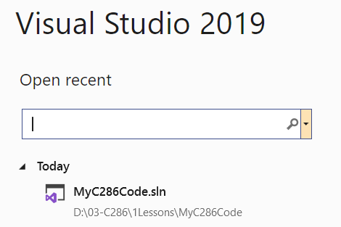

1. In the Solution Explorer, right-click on **Lesson12** and click **Set as Startup Project**. This is an important step. If you didn't perform this step, you will be running the previous web application.

# Setting up MS SQL Database

1. Create a database named **C286Lesson12** in your **(localdb)\ProjectsV13** database server.
2. Right-click on the database and open a **New Query…** . Run the provided script **DBSetup.txt** to create the database tables needed for today’s lesson.
3. You should be able to see the tables created as below.

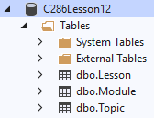

1. Close the **SQLQuery1.sql** window. You do not need to save any changes to this file.

**Configuring the Project**

1. In the Solution Explorer, double-click on **Lesson12**. Add the following lines of code in yellow. Remember to save the file by pressing [Ctrl]+[S].

|  |
| --- |
| <Project Sdk="Microsoft.NET.Sdk.Web">  <PropertyGroup>  <TargetFramework>net5.0</TargetFramework>  </PropertyGroup>  <ItemGroup>  <PackageReference Include="Microsoft.EntityFrameworkCore" Version="5.0.10" />  <PackageReference Include="Microsoft.EntityFrameworkCore.SqlServer" Version="5.0.10" />  <PackageReference Include="Microsoft.EntityFrameworkCore.Design" Version="5.0.10" />  <PackageReference Include="System.Data.SqlClient" Version="4.8.3" />  <PackageReference Include="Microsoft.AspNetCore.Mvc.NewtonsoftJson" Version="5.0.10" />  <PackageReference Include="Newtonsoft.Json" Version="13.0.1" />  <PackageReference Include="Newtonsoft.Json.Schema" Version="3.0.14" />  </ItemGroup>  </Project> |

Under the **Lesson12** Packages, check that the packages have been downloaded.

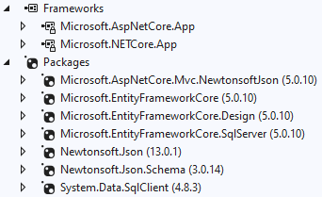

# Generating DbContext and Entity Classes

1. In the Solution Explorer, right-click on **Lesson12** and click **Open in Terminal**. You should see the **Developer Powershell** window appears in your Visual Studio.

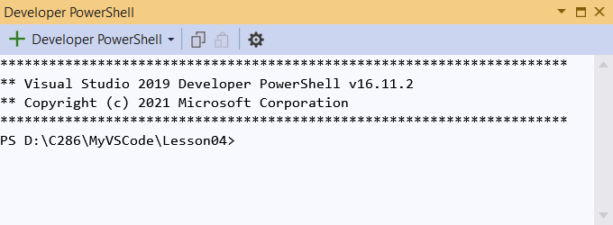

1. Copy the following one-liner command and paste into the **Developer Powershell** window. To paste is just to right-click within **Developer Powershell**. Press [Enter] to execute the command.

dotnet ef dbcontext scaffold "Data Source=(localdb)\ProjectsV13;Initial Catalog=C286Lesson12;Integrated Security=True" Microsoft.EntityFrameworkCore.SQLServer -o Models -c AppDbContext -f --no-onconfiguring --no-pluralize

1. In the Solution Explorer, under **Lesson12**, **Models**, verify the **AppDbContext** class and entity classes are generated as illustrated in the following diagram:

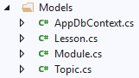

Do not continue if there is any error. Notify your Lecturer immediately.

**Configuring Startup.cs**

1. In the **Solution Explorer**, under **Lesson12**, double-click on the file **Startup.cs** and make the following changesso that the completed **Startup.cs** should look identical to the following code. Remember to save the file by pressing [Ctrl]+[S].
2. In the **Solution Explorer**, open the file **Startup.cs**, delete all the contents and paste the following lines of code. Remember to save the file by pressing [Ctrl]+[S].

|  |
| --- |
| using Microsoft.AspNetCore.Builder;  using Microsoft.AspNetCore.Hosting;  using Microsoft.EntityFrameworkCore;  using Microsoft.Extensions.Configuration;  using Microsoft.Extensions.DependencyInjection;  namespace Lesson12  {  public class Startup  {  public Startup(IConfiguration configuration)  {  Configuration = configuration;  }  public IConfiguration Configuration { get; }  public void ConfigureServices(IServiceCollection services)  {  services.AddControllersWithViews();  services.AddControllers().AddNewtonsoftJson();  services.AddDbContext<Lesson12.Models.AppDbContext>(  options =>  options.UseSqlServer(  Configuration.GetConnectionString("DefaultConnection")));    }  public void Configure(IApplicationBuilder app)  {  app.UseDeveloperExceptionPage();  app.UseDefaultFiles();  app.UseStaticFiles();  app.UseRouting();  app.UseAuthentication();  app.UseAuthorization();  app.UseEndpoints(routes =>  {  routes.MapControllerRoute (  name: "ViewByModuleIdLessonId",  pattern: "{moduleId}/{frLessonId:int}/{toLessonId:int?}",  defaults: new { controller = "RPNotes", action = "ListByModuleLesson" },  constraints: new { moduleId = @"[A-Za-z]\d{3}" });  routes.MapControllerRoute (  name: "ViewByModuleId",  pattern: "{moduleId}",  defaults: new { controller = "RPNotes", action = "ListByModule" },  constraints: new { moduleId = @"[A-Za-z]\d{3}" });  routes.MapControllerRoute (  name: "ViewByTopics",  pattern: "topic",  defaults: new { controller = "RPNotes", action = "TopicalIndex" });  routes.MapControllerRoute (  name: "Search",  pattern: ":{keyPhrase}",  defaults: new { controller = "RPNotes", action = "Search" });  routes.MapControllerRoute (  name: "rpNotesdefault",  pattern: "{controller=RPNotes}/{action=Index}/{id?}");  routes.MapControllerRoute (  name: "default",  pattern: "{controller=Home}/{action=Index}/{id?}");  });  }  }  } |

**Configuring appSettings.json file**

1. Right-click on the file appsettings.json and choose Open.
2. Remove the contents in appsettings.json.
3. Copy and paste the following code into appsettings.json.
4. Save and close the file.

|  |
| --- |
| {  "ConnectionStrings": {  "DefaultConnection": "Data Source=(localdb)\\ProjectsV13;Initial Catalog=C286Lesson12;Integrated Security=True"  }  } |

# Setting up Folders and Files

1. From the **code** folder in the problem package, perform the following operations to the Solution Explorer.
2. Drag the folder Controllers into **Lesson12**
3. Drag the folder Views into **Lesson12**
4. Drag the folder Utilsinto **Lesson12**
5. Drag the file libman.json into **Lesson12**
6. Drag the the following folders into **Lesson12\wwwroot**

* Attachments
* Demo
* Exercise1
* Exercise2
* images
* lib
* SoundFiles

Expand the wwwroot folder one more time and you should see a breakdown as follows:

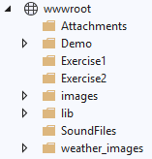

**Setting up Bootstrap and JQuery**

1. Right-click on the file **libman.json** and select "Restore Client-Side Libraries". The Javascript and CSS files will be downloaded to the wwwroot folder. Expand the wwwroot folder and you should be able to see the following folders:

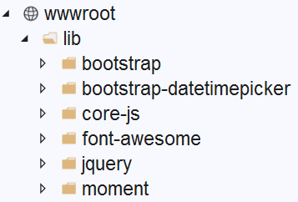

# Building and Running the Web App

1. Right-click **Lesson12** in the **Solution Explorer** and click **Rebuild**.
2. In the main menu bar of VS2019, click **View**, **Error List**. Make sure there is no error highlighted. If there are, fix them and repeat the previous step.
3. In solution explorer, right-click on the **Views > RPNotes > Index.cshtml**  and click on **View in Browser** menu item to launch the web app.
4. The following page will appear on your browser:

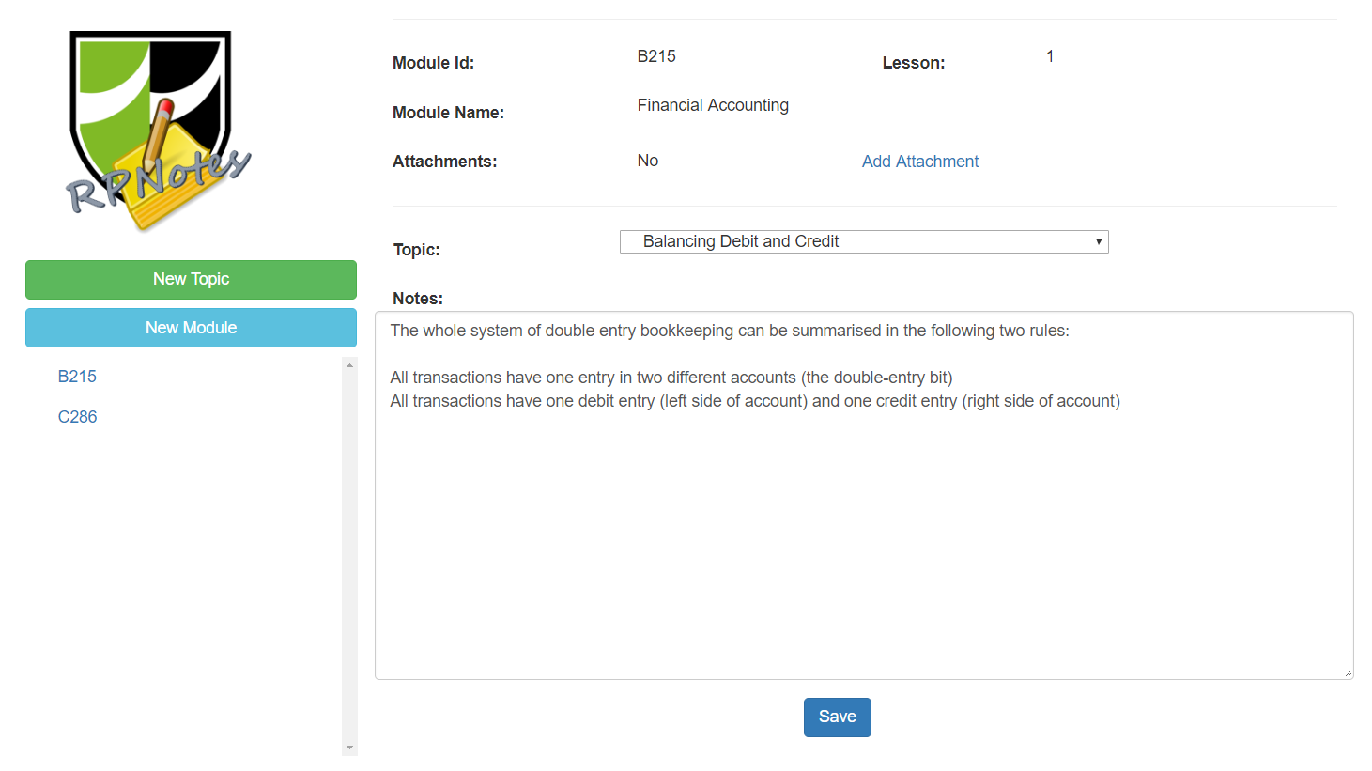

*— End of Setup Guide —*